What is biomass?
Biomass, a renewable energy source, is biological material from living, or recently living organisms, such as trees, crops, animals and plants, but also agricultural, urban and industrial wastes. Biomass is stored sun energy in the form of carbohydrates. All living things rely on that kind of energy.
Recently biomass has become one energy source to satisfy our growing energy need. Most of this biomass is used to gain electricity or heat while some of it is also used for the production of fibres or chemicals.

Why biomass?
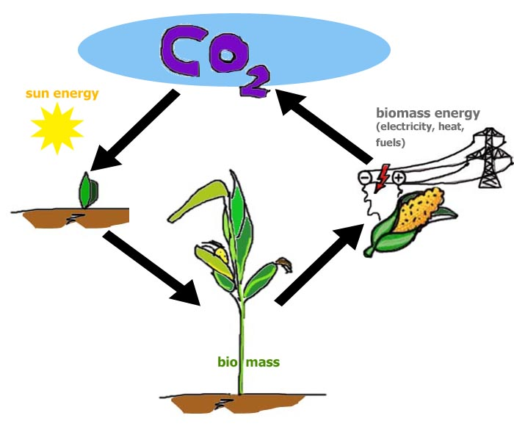
Soon there will be 8 billion people living on our globe. This is an incredible number thinking that only one hundred years ago there were not even 2 billions! Mankind has grown tremendously and so has the need for energy. Until 150 years ago biomass gave people all the energy they needed – food as well as heat. Today we satisfy this need mainly by using fossil fuels like natural gas or petroleum. Burning fossil fuels produces CO₂, a greenhouse gas. CO₂ and other greenhouse gases act like a blanket around our planet: they let sun energy in but don’t let the heat out again. Using biomass instead of fossil fuels is one possible way of reducing the CO₂ emissions on our planet.
Plants used for biomass energy take exactly the amount of CO₂ out of the atmosphere that that is set free when they are burned or when they rot.

Raw materials used as biomass can be either crops that are especially grown for that purpose or agricultural, municipal or industrial organic wastes. Using wastes also helps reducing the amount of waste that ends up in landfills.

Environmental impact of biomass
+ Using biomass as a source of energy helps reduce the overall output of greenhouse gases. Today, we know that this is true for most fast growing crops (e.g. corn) and for organic wastes but not necessarily for forests.
+ Using biomass can help reducing the amount of organic wastes
- Using biomass as a fuel produces air pollution in the form of carbon monoxide, NO_{x}(nitrogen oxides), particulates and other pollutants, in some cases at levels above those from traditional fuel sources such as coal or natural gas.
- Using biomass from forests often is not CO₂ neutral for it takes a long time for the trees to grow again.

Questions for discussion
- Is it ethical to burn biomass when in other places people starve to death?
- Wouldn’t atomic energy be a possible way to avoid the production of CO₂?

